Observa la ilustración y arrastra la opción correspondiente:

|  |
| --- |
| having coffee take a shower sleeping standing up shaving brushing teeth having dinner cleaning teeth dressing washing his face slicing vegetables making up comb hair make a pony tail making the bed undressing taking a bath going to bed doing breakfast eating a sandwich Doing meal |

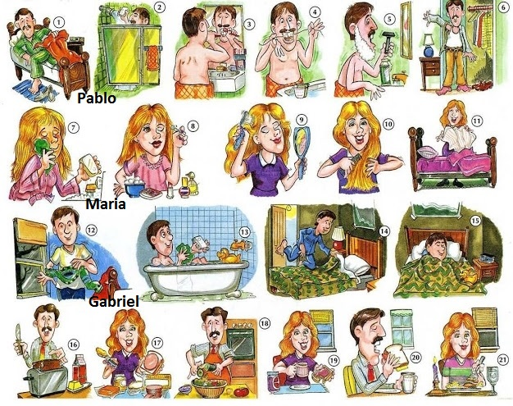

|  |  |  |
| --- | --- | --- |
| 1.- Standing up | 8.- | 15.- |
| 2.- | 9.- | 16.- |
| 3.- | 10 | 17.- |
| 4.- | 11.- | 18.- |
| 5.- | 12.- | 19.- |
| 6.- | 13.- | 20.- |
| 7.- | 14.- | 21.- |

Respuestas:

1.- standing up

2.- Take a shower

3.- shaving

4.- brushing teeth

5.- cleaning teeth

6.- dressing

7.- washing the face

8.- making up

9.- comb hair

10.- making the bed

11.- make a pony tail

12.- undressing

13.- taking a bath

14.- going to bed

15.- sleep

16.- doing breakfast

17.- Doing meal

18.- slicing vegetables

19.- having coffee

20. eating a sandwich

21.- having dinner